CE reports

CE Project Pending Intakes
The Pending Intakes contains a magnifying glass in the right-hand corner.
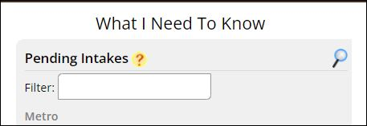
Click on the magnifying glass and this brings you directly to the Universal – Pending Intakes report. Select your report criteria, select the “View” you would like to see, Aggregate/summary is the default.
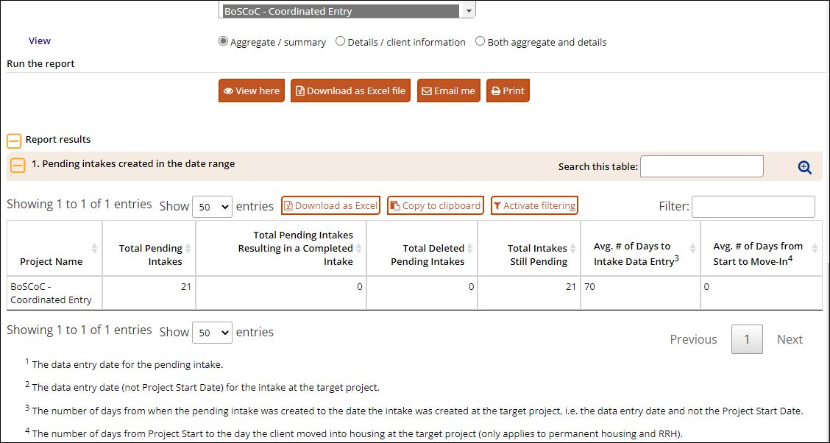
Set View to Details/client information so see client level information. Select Activate filtering feature to filter the information.
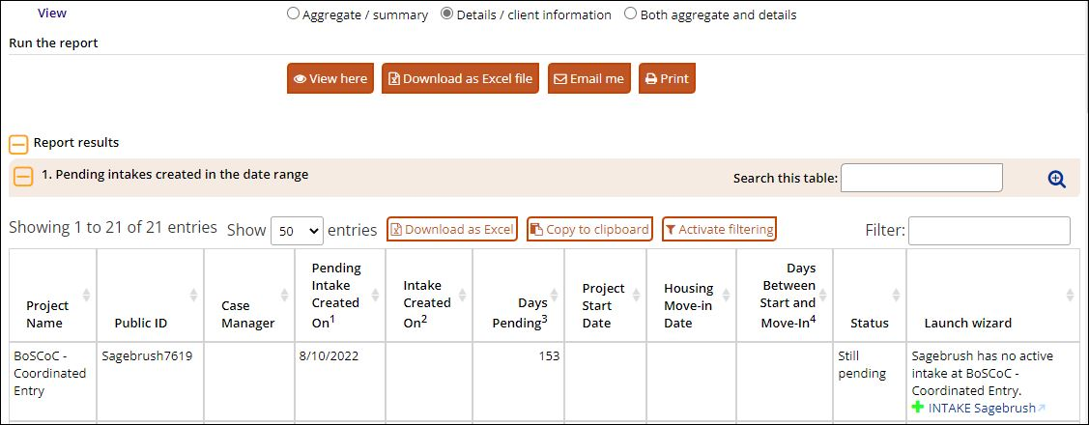
Select Both aggregate and details to display both sections of the report.
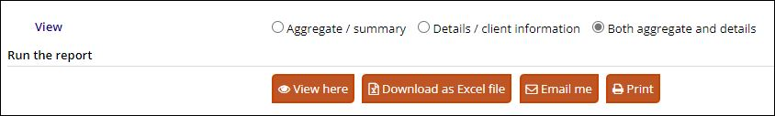
Select View here to display the report on screen or select your preferred option.

