How to create the RHY upload file
Click on the Reports feature located at the top of the screen.
Use the navigation list on the left side of the screen and choose “CSV”
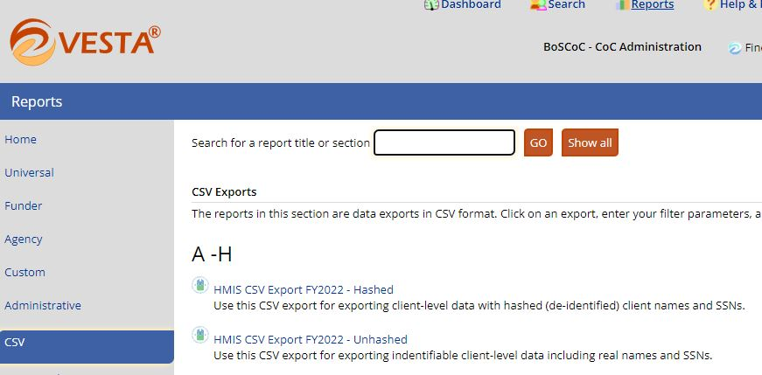
Select the “HMIS CSV Export FY2022 – Hashed” report
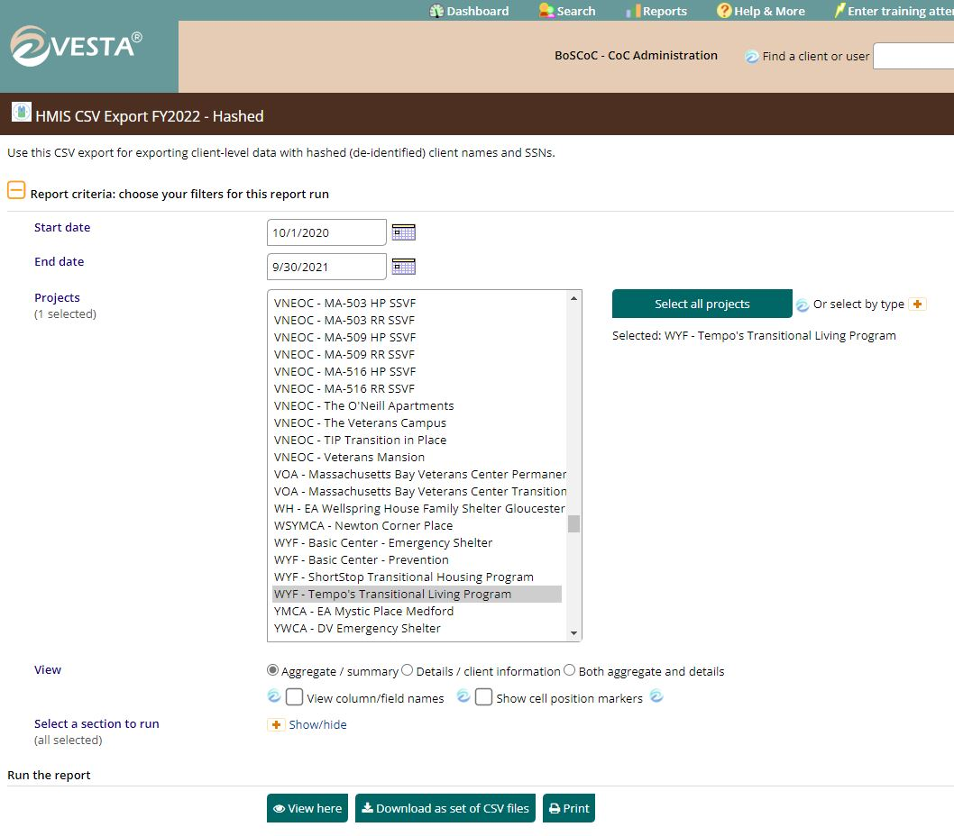

Enter your Start and End date
Select your project name
Leave the “View” selection default, Aggregate / Summary
Choose “View here” if you would like to review your data
Choose “Download as a set of CSV files”
Select “CLICK HERE TO DOWNLOAD IT”
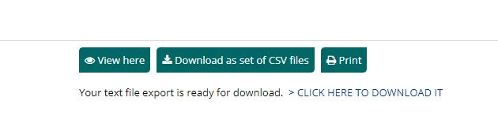


Save the CSV file and it’s a good idea to rename it.
As mentioned on slide 12 of the training materials
https://www.rhyttac.net/assets/docs/RHY-HMIS/2021/RHY-HMIS%20Launch%20Training%20PowerPoint%20%28November%202021%29.pdf
Grantee ID, RHY program, HMIS project Type, Report Period, User, so for example:
90cx72520100_TLP_TH_Spring23_AntwanS

Let us know if you have any questions.

