
Data – Storage/VESTAdocup

If you use an internet browser other than Microsoft Edge, you will need to download and install a browser extension to use VESTAdocup.
- If you use Google Chrome click here
- If you use Mozilla Firefox click here

Please note that VESTAdocup is a Windows application and will not run on a Macintosh.


To download and install VESTAdocup, you can either click HERE, or you can click “Scan using VESTAdocup” in VESTA from within a client Documents tab.
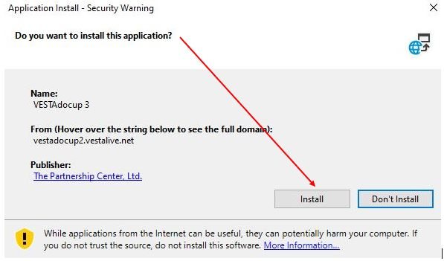

Depending on your system and browser, the installation might start right away or you might have to click on the downloaded file to open it. Once it starts, you’ll see the screen shown on the right. Just click Install.

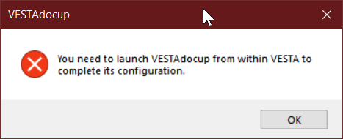
After you click the install button, your computer will download a few more installation files from VESTA and then launch VESTAdocup. You may or may not get this error message.

If you do, this is expected, as VESTAdocup is normally launched from within VESTA. Just click OK on this window, then VESTAdocup will open. Just click the X in the upper right or the “exit” button to close VESTAdocup.

Please don’t hesitate to contact us with any questions via mailto:support@vestama.zendesk.com

